Jacksonville and Anniston working on sewage treatment plant upgrades

[[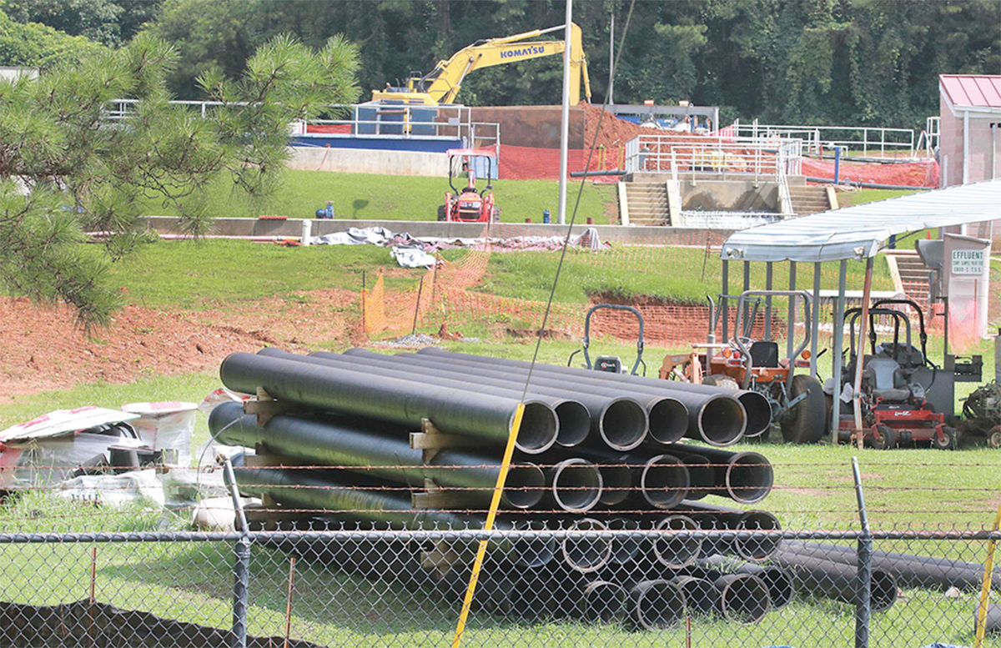](https://www.annistonstar.com/content/tncms/live/#1)](https://www.annistonstar.com/content/tncms/live/" \l "1)

Work continues at Jacksonville's wastewater treatment plant on Alabama 204.

* [Photo by Stephen Gross / The Anniston Star](https://www.annistonstar.com/users/profile/Stephen%20Gross)

Top of Form

Bottom of Form

[By Patrick McCreless, Star Staff Writer,](https://www.annistonstar.com/users/profile/Patrick%20McCreless)[pmccreless@annistonstar.com](mailto:pmccreless@annistonstar.com)

Sewage treatment plant upgrades announced last year are underway and on schedule in Jacksonville and are being planned in Anniston.

Jacksonville city officials said Monday their $10.1 million project to upgrade the city’s aging wastewater treatment plant should be finished in August next year as expected. Meanwhile, a similar, $12 million upgrade project for Anniston’s sewage treatment facility is being designed and will be bid out for construction in September, officials said.

Jacksonville Mayor Johnny Smith said the upgrade project began in December.

“I’d say we’re no more than 30 percent complete ... we’re basically on schedule,” Smith said.

Both cities announced in October that they had received loans through the Alabama Department of Environmental Management to cover the upgrade costs. The cities’ water and sewer boards have also approved rate increases to repay the loans.

Jarrod Simmons, Jacksonville city administrator, said it was past time to overhaul the treatment plant. The last time the plant was upgraded was in 1993, Simmons said.

“That was a 20-year upgrade and now it’s on 24 years,” Simmons said.

Smith said that so far, crews have demolished old buildings and almost erected two new ones.

“One is for lab work to test the water,” Smith said.

The other building will house a press needed to more quickly dry out sludge before it is removed from the plant for disposal, Smith said.

“We’ve just been putting the sludge on beds outside to dry, but that exposes them to rain, which just gets it wet again,” Smith said.

Smith said workers are just starting on the main part of the project installing new equipment used to treat sewage. He said that part of the project will take longer because treatment must continue at the plant while work takes place.

Like Jacksonville, Anniston’s Choccolocco Creek Wastewater Treatment Plant needs replacements for aging equipment. Also like Jacksonville’s project, the upgrades at Anniston’s plant will improve efficiency and lower operating costs.

Ed Turner, general manager for the Anniston Water Works and Sewer Board, said that the design work has been underway for months and once it’s done, the project should take about 18 months to complete.

“It’s just time-consuming ... we want to make sure it’s done right,” Turner said of the design process.

***Staff writer Patrick McCreless: 256-235-3561. On Twitter***[***@PMcCreless_Star***](http://www.twitter.com/PMcCreless_Star)***.***